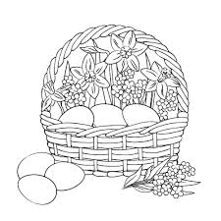
2022 Brazos Valley Bluebonnet Egg Show
WHEN:
Saturday January 8th, 2022

LOCATION:
Grimes County Fair Grounds
5220 FM 3455 Rd
Navasota, TX 77868

SCHEDULE:
8:30-9:30am – Registration, sign in and drop off your eggs
10:00am – LIVE Contents Judging BEGINS
11-11:30am – Egg show Classification Judges comments
11:30am – Champions Row

EGG CLASSES
The show features three main judging divisions, the SHELL Classes, the CONTENTS Classes. The classes are divided by color and size, including both large fowl and bantam sized eggs, with categories that anyone can enter, even if you just have one egg. Sage Talavera is our esteemed Egg Show judge and is available for questions before and after the show.
SHELL Classes are divided into White Class, Brown Class, and Colors Class, including blues, greens, olives, pinks, pastels, and tinted. The Tricolor Class requires three different colors or shades of eggs in each entry. The Single Egg Class includes single eggs from your chickens and all other kinds of poultry. If you have an odd egg, small egg, large egg, beautiful egg, this is the Class to enter.
CONTENTS Classes in both bantam and large fowl will be judged on their interior qualities. A single egg entry is cracked open and judged on the color, shape and form of the yolk and albumin, and on the freshness and visibility of the structures of the egg. Pick your freshest egg and see how it stands up to the rest!
DECORATING Classes – go wild and use your imagination. We will have two classes: a judge’s choice for single-egg best use of color, decorations and creativity. Secondly the People’s choice for best single or multi-Egg themed (diorama) presentation.
AWARDS
A Grand Champion, Reserve Champion and Junior Champion will be awarded at the conclusion of the show, based on cumulative points. Coyote Creek Farms has partnered with us to provide category prizes. The more entries you make, the more points you earn towards the top honors.
Points for this show will count toward the Texas Annual Bluebonnet Egg Show competition.

MAIL ENTRY AND FEES TO: Bluebonnet Poultry Show C/O Claudia Choate
1489 C.R. 308 Lexington, TX 78947-4190
OR BRING THE DAY OF SHOW
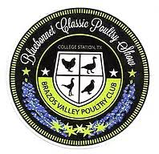
2022 Brazos Valley Bluebonnet Egg Show
ENTRY FORM
MAIL ENTRY AND FEES TO:
Bluebonnet Poultry Show C/O Claudia Choate
1489 C.R. 308 Lexington, TX 78947-4190
OR BRING THE DAY OF SHOW
Questions – Please Call Shawn Johnson 208 630-3488
or email skonifarms@gmail.com

Class | Egg | Number Entered
Class 1 | Bantam White
Class 2 | Bantam Brown
Class 3 | Bantam All Other Colors
Class 4 | Standard White
Class 5 | Standard Brown
Class 6 | Standard All Other Colors
Class 7 | Trio Of Colors
Class 8 | Standard/Bantam Single Egg
Class 9 | Bantam Content
Class 10 | Standard Content
Class 11 | Decorative Single Egg
Class 12 | Decorative Diorama
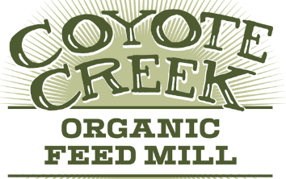
*** Please note class 1 – 7 need 3 eggs per entry
*** Class 7 is made up of three eggs – each egg a different color
*** Class 8, 9, and 10 one egg per entry
*** Class 11 single-egg best use of color, decorations and creativity
*** Class 12~ one or multiple eggs in a themed (diorama) presentation
NAME ___________________________________________________________

ADDRESS _______________________________________________________

ADDRESS _______________________________________________________

CONTACT NUMBER ______________________________________________

TOTAL Entries _____ @ $3.5 each = $ _______________ CLASS: _______(Open/JR)
ADD $1.00 for entries submitted after Dec 26, 2019.
Makes checks payable to: B.V.P.C. or they can be included in the BLUEBONNET CLASSIC ENTRY FORM poultry entry

